

**Business Requirements Document**

**For News Portal**

**Version: 1.5**

**March 2021**

Revision History

|  |  |  |  |
| --- | --- | --- | --- |
| **Date** | **Version** | **Author** | **Change Description** |
| 21 May 2018 | 0.1 | Ngu Nguyen | Requirements of phase 1.1 |
| 22 May 2018 | 0.2 | Ngu Nguyen | Update due to client’s comments from requirements walkthrough session |
| 23 May 2018 | 1.0 | Ngu Nguyen | Update due to client’s review |
| 1 June 2018 | 1.1 | Ngu Nguyen | Requirements of phase 1.2 |
| 20 June 2018 | 1.2 | Ngu Nguyen | Update due to client’s comments from requirements walkthrough session |
| 20 July 2018 | 1.3 | Ngu Nguyen | Update due to client’s review |
| 14 August 2018 | 1.4 | Ngu Nguyen | Update due to client’s review |
| 7 September 2018 | 1.5 | Ngu Nguyen | Update impression limit settings for ads |

**Table of Contents**

1. Introduction 7

1.1 Purpose 7

1.2 Overview 7

1.3 Intended Audience and Reading Suggestions 7

1.4 Abbreviations 7

1.5 References 7

2. High Level Requirements 8

2.1 Object Relationship Diagram 8

2.2 Workflow 9

2.3 Site Map 10

2.4 Security Matrix 10

2.5 Constraints & Assumptions 11

2.5.1 Constraints 11

2.5.2 Assumptions 11

3. Mockup Screens 12

3.1 Header 12

3.2 Top Navigation Bar 13

3.3 Breadcrumb 13

3.4 Footer 14

3.5 Home Page 16

3.5.1 Banner 16

3.5.2 Trending Post 17

3.5.3 Blog of The Day 19

3.5.4 Top Articles 20

3.5.5 Thailand National Lottery 21

3.5.6 Advertisement (horizontal) 22

3.5.7 Bloggers Rabbit 22

3.5.8 Upcoming Events 24

3.5.9 Advertisement (block) 25

3.5.10 Videos Today 26

3.5.11 Podcast 27

3.6 Category Landing 29

3.6.1 Featured Articles 29

3.6.2 Trending Post 30

3.6.3 Advertisement (horizontal) 30

3.6.4 Blogger Rabbit 30

3.6.5 Upcoming Events 30

3.6.6 Advertisement (block) 30

3.6.7 Videos Today 30

3.6.8 Podcast 30

3.7 Article Details 31

3.7.1 Article Details 31

3.7.2 Advertisement (horizontal) 33

3.7.3 You May Like 33

3.7.4 Advertisement (block) 34

3.7.5 Trending Post 34

3.8 Events Landing 34

3.8.1 Featured Events 34

3.8.2 Upcoming Events (vertical) 36

3.8.3 Advertisement (horizontal) 37

3.8.4 Around The World 37

3.8.5 Advertisement (block) 38

3.8.6 Latest Events 38

3.8.7 Advertisement (block) 39

3.9 Events Details 40

3.9.1 Event Details 40

3.9.2 Advertisement (horizontal) 42

3.9.3 Related Events 42

3.10 Generic Pages 43

3.10.1 Blank Page 43

3.11 Search 44

3.11.1 Search Bar 44

3.11.2 Search Results 45

3.12 Video/Podcast Details 48

3.12.1 Video/Podcast Details 48

3.12.2 You May Like 50

3.12.3 Advertisement (block) 51

3.12.4 Trending Post 51

4. Use Case Specifications 52

4.1 Back-end 52

4.1.1 Create draft content 52

4.1.2 Edit content 53

4.1.3 Delete content 54

4.1.4 Submit content 55

4.1.5 Publish content 56

4.1.6 Reject content 57

4.1.7 Unpublish content 58

4.1.8 Scheduled Publish content 59

4.2 Rabbit Today site 60

4.2.1 Search 60

4.2.2 Subscribe (Email) 62

4.2.3 Like content 63

4.2.4 Unlike content 64

4.2.5 Share content 65

4.3 Ads Management 65

5. Data Templates 68

5.1 Article 68

5.2 Event 68

5.3 Video/Podcast 69

6. Non-Functional Requirements 70

6.1 Performance Requirements (optional) 70

6.2 Safety Requirements (optional) 70

6.3 Security Requirements (optional) 70

6.4 Software Quality Attributes (optional) 70

7. Integration 70

7.1 Google Analytics 70

8. Appendices 71

8.1 Messages List 71

8.2 Email Templates 71

8.3 Snippet 72

8.3.1 Quote 72

# Introduction

## Purpose

The will:

* Define the scope of business objectives, business functions, and organizational units covered,
* Identify the business processes that the solution must facilitate,
* Facilitate a common understanding of what the functional requirements are for all parties involved,
* Establish a basis for defining the acceptance tests for the solution to confirm that what is delivered meets requirements.

The purpose of the document is to collect and analyse all assorted ideas that have come up to define the system, its requirements with respect to consumers. Also, we shall predict and sort out how we hope this product will be used in order to gain a better understanding of the project, outline concepts that may be developed later, and document ideas that are being considered, but may be discarded as the product develops.

## Overview

Rabbit Today phase 1 is to build a portal website, which leading with content generated by our writer, contracted blogger. Rabbit Today is the trusted and curated content provider from leading bloggers and influencers’ network with multi-channels platform for driving O2O marketing performance.

At the 1st phase, all content will be managed by Rabbit Today’s editors. There is no membership required for end user at this phase.

## Intended Audience and Reading Suggestions

This document is intended for:

* End users: Responsible to verify that business requirements have been documented here completely, accurately and unambiguously
* Development team: Responsible to develop detailed design, implement and perform unit test, integration test and system test for the application
* UAT team: Responsible to conduct user acceptance test sessions with end users

## Abbreviations

|  |  |
| --- | --- |
| **Acronym** | **Reference** |
| TBD | **T**o **B**e **D**efined |

## References

N/A

# High Level Requirements

This section describes the general overview of the system functions or business processes which are depicted in different diagrams. It shows the types of users, their granted permissions to perform specific system functions and the sequence required to complete a business workflow (if any). As the section name implies, it is high-level which mean not detailed enough. For detailed requirement specification, please see section **Use Case Specifications**.

## Object Relationship Diagram

This section shows the static relationship between each object in the system. An object could be described as an instance of a particular entity in the system.

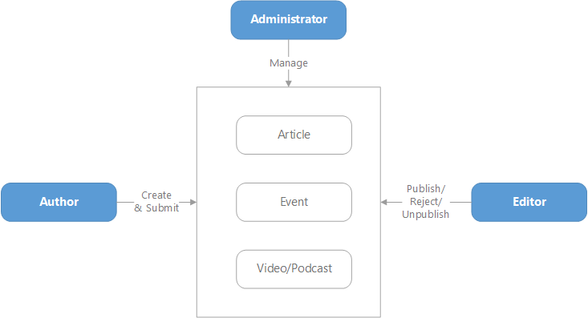

Figure 1: Object Relationship Diagram

## Workflow

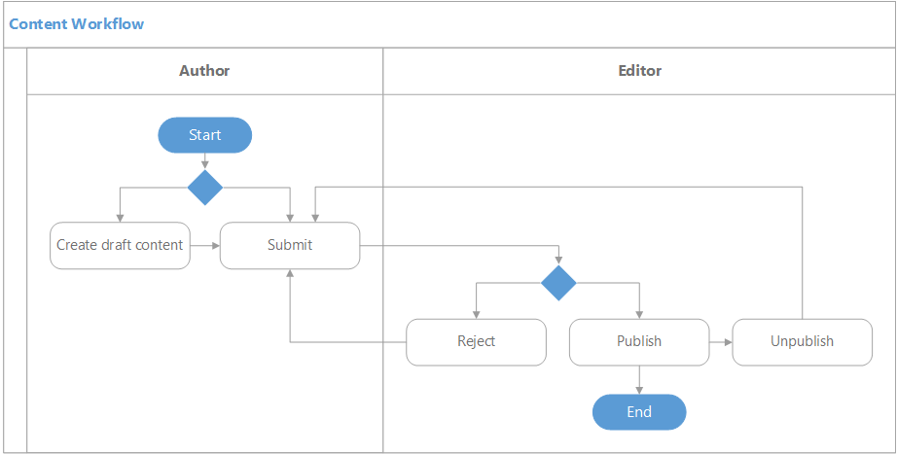

Figure 2: Content Workflow Diagram

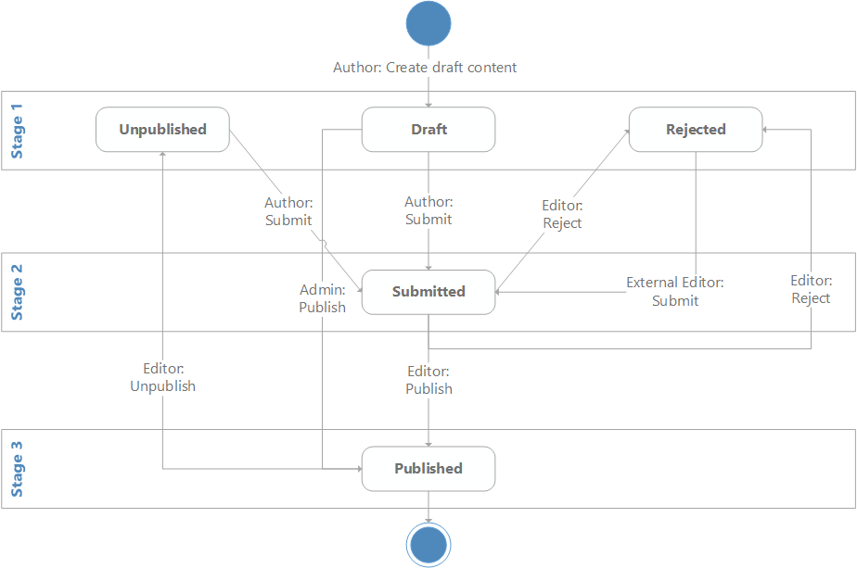

Figure 3: Content State Transition Diagram

## Site Map

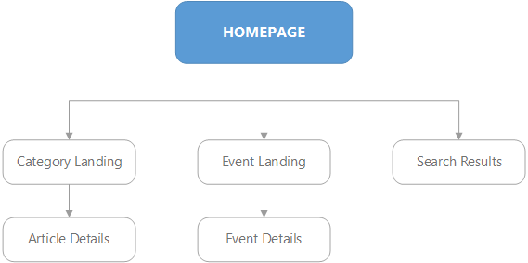

Figure 4: Sitemap

## Security Matrix

| **User**  **Permission** | **Author** | **Editor** | **Administrator** |
| --- | --- | --- | --- |
| x 1: Item created by himself | | | |
| Create | x | x | x |
| Status: **Draft, Rejected, Unpublished** | | | |
| View | x | x | x |
| Edit | x 1 | x | x |
| Delete | x 1 | x | x |
| Submit | x 1 | x | x |
| Status: **Submitted** | | | |
| View | x | x | x |
| Edit | - | x | x |
| Delete | - | x | x |
| Publish | - | x | x |
| Reject | - | x | x |
| Status: **Published** | | | |
| View | x | x | x |
| Edit | - | - | - |
| Delete | - | - | - |
| Unpublish | - | x | x |

## Constraints & Assumptions

### Constraints

N/A

### Assumptions

#### Design Assumptions

* In case of functionality conflicts between the template and scope documents, the agreed template will be followed.

#### Data Assumptions

The scope does not contain:

* Migrating any old data
* Importing any data
* Configuring SEO related options for any product

# Mockup Screens

This section contains the screens and their respective attributes associated with one or more use cases defined in **Use Case Specifications** section.

## Header



Screen 1: Header

|  |  |  |  |  |
| --- | --- | --- | --- | --- |
| **#** | **Component** | **Description** | **CMS** | |
|  | **Editable in Experience Editor** |
| 1 | Logo | * Logo of Rabbit Today * After clicking the logo, navigate user to **Home Page** | Able to edit logo | Able to edit logo |
| 2 | **Main Navigation** | | | |
| 2.1 | Blogger Community | *(This feature* *is not available in phase 1. Therefore, as of now, disable this link)* | Able to edit link, title | Able to edit link, title |
| 2.2 | E-Commerce | *(This feature is not available in phase 1. Therefore, as of now, disable this link)* | Able to edit link, title | Able to edit link, title |
| 3 | **Today Date/ Temperature/ Weather** | | | |
| 3.1 | Date | Display today date as following format (regardless of site language):  ddd d MMM (upper case)  e.g. MON 20 JAN |  |  |
| 3.2 | Temperature | * Display temperature in detected location of current user * If location is not available, display temperature in Bangkok, Thailand * Temperature is in Celsius degree * Temperature information is get from given API: <http://data.tmd.go.th/api/Weather3Hours/>   V2/?uid=api&ukey=api12345 |  |  |
| 4 | **Personal Features** | | | |
| 4.1 | Language Switcher | * Allow user to switch content language between English & Thai by clicking on the label * Options:   + EN (English)   + TH (Thai) – default value   *(This feature is not available in phase 1. Therefore, as of now, disable this link)* |  |  |
| 4.2 | Profile | *(This feature is not available in phase 1. Therefore, as of now, disable this link)* |  |  |
| 4.3 | Shopping Cart | *(This feature is not available in phase 1. Therefore, as of now, disable this link)* |  |  |
| 4.4 | Search | * After clicking the icon, display search bar * Refer to Screen 26: Search Bar |  |  |

## Top Navigation Bar



Screen 2: Top Navigation Bar

|  |  |  |  |  |
| --- | --- | --- | --- | --- |
| **#** | **Component** | **Description** | **CMS** | |
|  | **Editable in Experience Editor** |
| 1 | Top Bar | E.g.: News, Money & Biz, Looks, Taste etc.   * After clicking on the navigation bar, system will navigate user to corresponding **Category Landing** page * Including **Promotions**: After clicking this, navigate user to **Promotions** page (using **Category Landing** page template) | Able to manage, add/remove/order top menu (able to edit title, image background for each menu) | Able to edit title, image background of each menu |

## Breadcrumb



Screen 3: Breadcrumb

## Footer

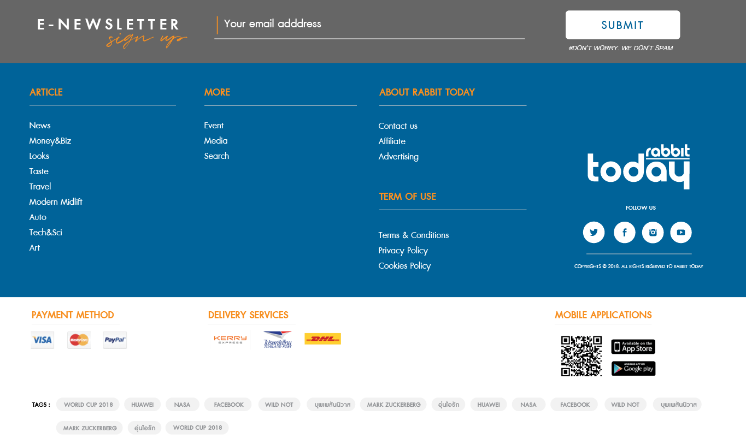

Screen 4: Footer

|  |  |  |  |  |
| --- | --- | --- | --- | --- |
| **#** | **Component** | **Description** | **CMS** | |
|  | **Editable in Experience Editor** |
| 1 | **Email Subscription** | | | |
| 1.1 | Section Title |  | Able to edit title | Able to edit title |
| 1.2 | **Your email address** textbox |  | Able to edit placeholder | Able to edit placeholder |
| 1.3 | **Submit** button | * Allow user to register his email address for subscription   Refer to   * Subscribe (Email) | Able to edit button label | Able to edit button label |
| 1.4 | Description | E..g: ‘#DON’T WORRY. WE DON”T SPAM’ | Able to edit text | Able to edit text |
| 2 | **Navigation, Social Channels** | | | |
| 2.1 | Useful Navigation Links | * There are four fixed sections as follows:   + Article   + More   + About Rabbit Today   + Term of Use | * Able to edit section title * Able to add/remove useful links in each section | * Able to edit section title * Able to add/remove useful links in each section |
| 2.2 | Footer Logo |  | Able to edit logo | Able to edit logo |
| 2.3 | Social Channels | * Display first four social channels which are configured in backend * There are four social channels by default as follows:   + Facebook   + Twitter   + Instagram   + Youtube | * Able to manage, add/remove social channels * Able to edit title (e.g. ‘FOLLOW US’) | * Able to manage, add/remove social channels * Able to edit title (e.g. ‘FOLLOW US’) |
| 2.4 | Copyrights |  | Able to edit text | Able to edit text |
| 3 | **Payment Methods, Delivery Services, Mobile Applications, Tags**  *‘Payment Method’, ‘Delivery Services’ & ‘Mobile Applications’ are hidden in phase 1.* | | | |
| 3.1 | Payment Method | Display payment methods (image only, no hyperlink) which are configured in backend | * Able to manage, add/remove payment method * Able to edit title (e.g. ‘PAYMENT METHOD’) | * Able to manage, add/remove payment method * Able to edit title (e.g. ‘PAYMENT METHOD’) |
| 3.2 | Delivery Services | Display delivery services (image only, no hyperlink) which are configured in backend | * Able to manage, add/remove delivery services * Able to edit title (e.g. ‘DELIVERY SERVICES’) | * Able to manage, add/remove delivery services * Able to edit title (e.g. ‘DELIVERY SERVICES’) |
| 3.3 | **Mobile Applications** | | | |
| 3.3.1 | QR Code | Generate link to QR code format | Able to edit link |  |
| 3.3.2 | Download link on App Store | Mobile application download link from App Store | Able to edit link |  |
| 3.3.3 | Download link on Google Play | Mobile application download link from App Store | Able to edit link |  |
| 4 | Tags | Populate 20 unique tags from most viewed contents (articles, events, video/podcast) by default | * Using Sitecore tags * Able to edit number of shown tags (default is 20) * Able to edit title (e.g. ‘TAGS’) | Able to edit title (e.g. ‘TAGS’) |

## Home Page

### Banner



Screen 5: Banner

|  |  |  |  |  |
| --- | --- | --- | --- | --- |
| **#** | **Component** | **Description** | **CMS** | |
|  | **Editable in Experience Editor** |
| 1 | **Banners** slider | * Banners might be images or embedded Youtube video link * Auto slide every 5 seconds * If banner is an image, after clicking on the banner, navigate to corresponding page * If banner is an embedded Youtube video, play the video in a lightbox (using Iframe Player API) | * Able to manage, add/remove banner * Able to manage banner sequence, auto-slide interval time * For each banner, following information is configurable:   + Image   + Link   + Target (new window, same window, new tab) |  |

### Trending Post

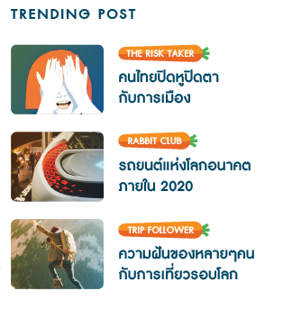

Screen 6: Trending Post

|  |  |  |  |  |
| --- | --- | --- | --- | --- |
| **#** | **Component** | **Description** | **CMS** | |
|  | **Editable in Experience Editor** |
| 1 | **Trending Post** list | * Display top 3 articles which satisfy selected filter option (only 1 option can be selected):  |  |  | | --- | --- | | **Filter Option** | **Logic** | | Most recent | Latest published articles (based on published time) | | Top view in past 7 days | Articles which have most viewed in the past 7 days | | Manual | Manually picked by administrator/editor in the backend |  * Each article displays following information:   + Thumbnail Image   + Category   + Name * After clicking on any article (thumbnail image/ name), navigate user to corresponding **Article Details** page | * Able to edit section title * Able to select filter option | Able to edit section title |

### Blog of The Day

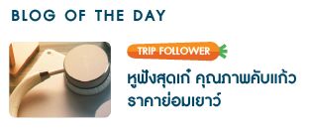

Screen 7: Blog of The Day

|  |  |  |  |  |
| --- | --- | --- | --- | --- |
| **#** | **Component** | **Description** | **CMS** | |
|  | **Editable in Experience Editor** |
| 1 | Blog of The Day | * Display top 1 article which satisfies selected filter option (only 1 option can be selected):  |  |  | | --- | --- | | **Filter Option** | **Logic** | | Most recent | Latest published article (based on published time) | | Manual | Manually picked by administrator/editor in the backend |  * The article displays following information:   + Thumbnail Image   + Category   + Name * After clicking on the article (thumbnail image/ name), navigate user to corresponding **Article Details** page | * Able to edit section title * Able to select filter option | Able to edit section title |

### Top Articles

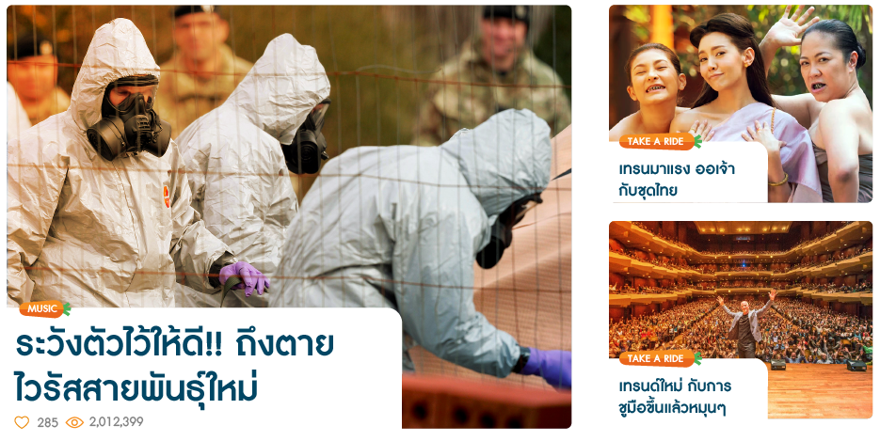

Screen 8: Top Articles

|  |  |  |  |  |
| --- | --- | --- | --- | --- |
| **#** | **Component** | **Description** | **CMS** | |
|  | **Editable in Experience Editor** |
| 1 | Top Articles | * Display top 3 articles which satisfy selected filter option (only 1 option can be selected):  |  |  | | --- | --- | | **Filter Option** | **Logic** | | Top view in past 30 days | Articles which have most viewed in the past 30 days | | Top like in past 30 days | Articles which have most liked in the past 30 days | | Manual | Manually picked by administrator/editor in the backend |  * Each article displays following information:   + Thumbnail Image   + Category   + Name   + Number of likes   + Number of views * After clicking on any article (thumbnail image/ name), navigate user to corresponding **Article Details** page | * Able to edit section title * Able to select filter option | Able to edit section title |

### Thailand National Lottery

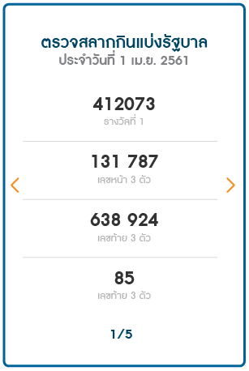

Screen 9: Thailand National Lottery

|  |  |  |  |  |
| --- | --- | --- | --- | --- |
| **#** | **Component** | **Description** | **CMS** | |
|  | **Editable in Experience Editor** |
| 1 | Images slider | * Multiple images * Able to slide left/right * Auto slide every 5 seconds | Able to edit images |  |

### Advertisement (horizontal)



Screen 10: Advertisement (horizontal)

|  |  |  |  |  |
| --- | --- | --- | --- | --- |
| **#** | **Component** | **Description** | **CMS** | |
|  | **Editable in Experience Editor** |
| 1 | Advertisement | * Images only * Auto switch every 5 seconds * After clicking on the advertisement, navigate to corresponding page * For Ads management requirements, refer to 4.3 | * Able to manage, add/remove advertisements * Able to manage auto-switch interval time |  |

### Bloggers Rabbit

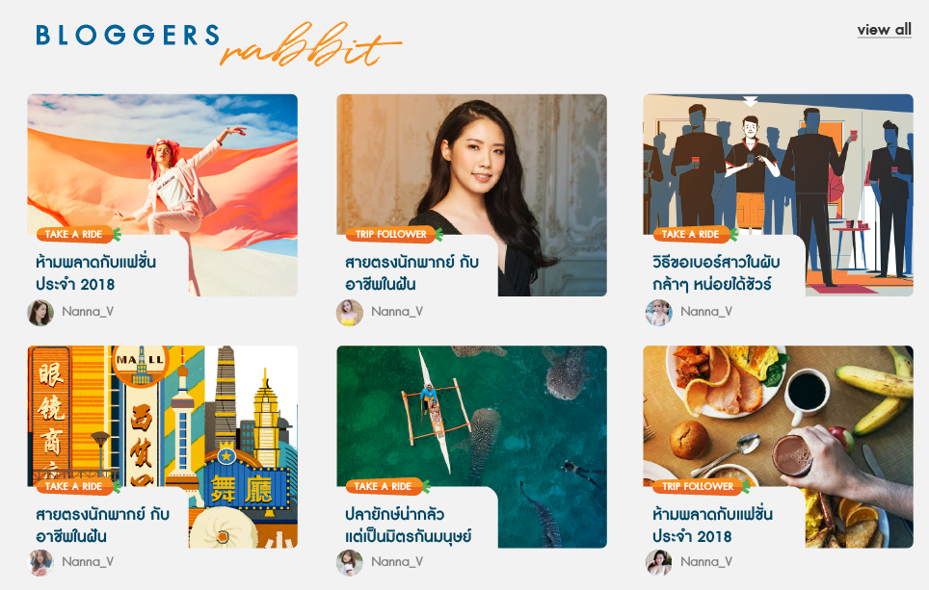

Screen 11: Bloggers Rabbit

|  |  |  |  |  |
| --- | --- | --- | --- | --- |
| **#** | **Component** | **Description** | **CMS** | |
|  | **Editable in Experience Editor** |
| 1 | Section Title |  | Able to edit title | Able to edit title |
| 2 | **Bloggers Rabbit** list | * Display top 12 articles from all categories and satisfy selected filter option (only 1 option can be selected):  |  |  | | --- | --- | | **Filter Option** | **Logic** | | Most recent | Latest published articles (based on published time) | | Top view in past 30 days | Articles which have most viewed in the past 30 days | | Top like in past 30 days | Articles which have most liked in the past 30 days | | Manual | Manually picked by administrator/editor in the backend |  * Each article displays following information:   + Thumbnail Image   + Category   + Name   + Creator (avatar & name) * After clicking on any article (thumbnail image/ name), navigate user to corresponding **Article Details** page | * Able to edit section title * Able to select filter option | Able to edit section title |
| 3 | **Load more** link | * After clicking the link, display 6 more articles * If there is no more articles to load, hide this link button | Able to edit display text (e.g. ‘Load more’) | Able to edit display text (e.g. ‘Load more’) |

### Upcoming Events

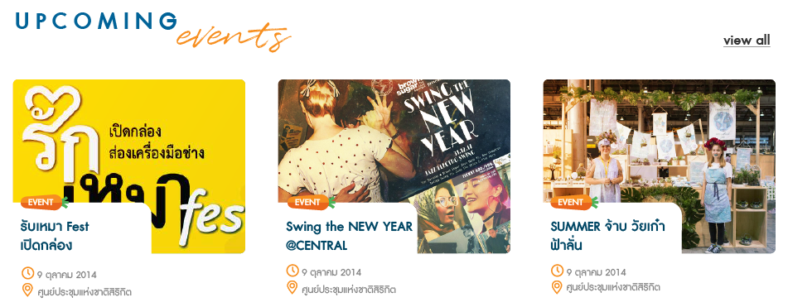

Screen 12: Upcoming Events

|  |  |  |  |  |
| --- | --- | --- | --- | --- |
| **#** | **Component** | **Description** | **CMS** | |
|  | **Editable in Experience Editor** |
| 1 | Section Title |  | Able to edit title | Able to edit title |
| 2 | **Upcoming Events** list | * Display top 3 upcoming events (nearest to today) * Each event display following information:   + Thumbnail image   + Category   + Name   + Start Date   + Venue * After clicking on any event (thumbnail image/ name), navigate user to corresponding **Event Details** page |  |  |
| 3 | **view all** link | After clicking the link, navigate to **Events Landing** page | Able to edit display text (e.g. ‘view all’) | Able to edit display text (e.g. ‘view all’) |

### Advertisement (block)



Screen 13: Advertisement (block)

|  |  |  |  |  |
| --- | --- | --- | --- | --- |
| **#** | **Component** | **Description** | **CMS** | |
|  | **Editable in Experience Editor** |
| 1 | Advertisement | * Images only * Auto switch every 5 seconds * After clicking on the advertisement, navigate to corresponding page * For Ads management requirements, refer to 4.3 | * Able to manage, add/remove advertisements * Able to manage auto-switch interval time |  |
| 2 | ‘advertising’ label |  | Able to edit label | Able to edit label |

### Videos Today



Screen 14: Videos Today

|  |  |  |  |  |
| --- | --- | --- | --- | --- |
| **#** | **Component** | **Description** | **CMS** | |
|  | **Editable in Experience Editor** |
| 1 | Section Title |  | Able to edit title | Able to edit title |
| 2 | **Featured Videos** list | * Display top 3 videos which satisfy selected filter option (only 1 option can be selected):  |  |  | | --- | --- | | **Filter Option** | **Logic** | | Most recent | Latest published videos (based on published time) | | Manual | Manually picked by administrator/editor in the backend |  * Each video displays following information:   + Thumbnail Image   + Category   + Name   + Number of likes   + Number of views * After clicking on any video (thumbnail image/ name), navigate user to corresponding **Video Details** page |  |  |
| 3 | **view all** link | *(This feature is not in scope. Therefore, as of now, disable this link)* | Able to edit display text (e.g. ‘view all’) | Able to edit display text (e.g. ‘view all’) |

### Podcast

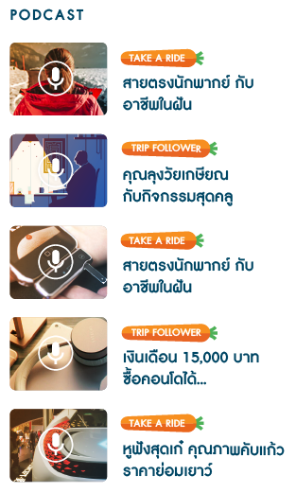

Screen 15: Podcast

|  |  |  |  |  |
| --- | --- | --- | --- | --- |
| **#** | **Component** | **Description** | **CMS** | |
|  | **Editable in Experience Editor** |
| 1 | Section Title |  | Able to edit title | Able to edit title |
| 2 | **Featured Podcast** list | * Display top 5 podcasts which satisfy selected filter option (only 1 option can be selected):  |  |  | | --- | --- | | **Filter Option** | **Logic** | | Most recent | Latest published videos (based on published time) | | Manual | Manually picked by administrator/editor in the backend |  * Each podcast displays following information:   + Thumbnail Image   + Category   + Name * After clicking on any podcast (thumbnail image/ name), navigate user to corresponding **Video Details** page |  |  |

## Category Landing

### Featured Articles

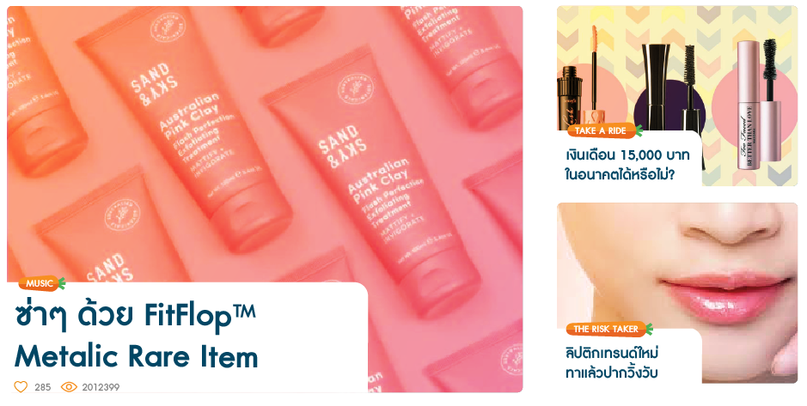

Screen 16: Featured Articles

|  |  |  |  |  |
| --- | --- | --- | --- | --- |
| **#** | **Component** | **Description** | **CMS** | |
|  | **Editable in Experience Editor** |
| 1 | Featured Articles | * Display top 3 articles of corresponding category which satisfy selected filter option (only 1 option can be selected):  |  |  | | --- | --- | | **Filter Option** | **Logic** | | Most recent | Latest published articles (based on published time) | | Top view in past 7 days | Articles which have most viewed in the past 7 days | | Top like in past 7 days | Articles which have most liked in the past 7 days | | Manual | Manually picked by administrator/editor in the backend |  * Each news displays following information:   + Thumbnail Image   + Category   + Name   + Number of likes   + Number of views * After clicking on any article (thumbnail image/ name), navigate user to corresponding **Article Details** page |  |  |

### Trending Post

Refer to 3.5.2. Articles belong to corresponding category.

### Advertisement (horizontal)

Refer to 3.5.6

### Blogger Rabbit

Refer to 3.5.7. Articles belong to corresponding category.

### Upcoming Events

Refer to 3.5.8

### Advertisement (block)

Refer to 3.5.9

### Videos Today

Refer to 3.5.10

### Podcast

Refer to 3.5.11

## Article Details

### Article Details

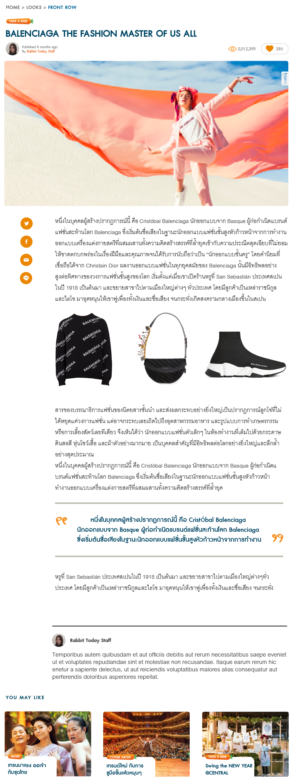

Screen 17: Article Details (full mode)

|  |  |  |  |  |
| --- | --- | --- | --- | --- |
| **#** | **Component** | **Description** | **CMS** | |
|  | **Editable in Experience Editor** |
| 1 | Category |  |  |  |
| 2 | Name | Upper case |  |  |
| 3 | **Creation Information** | | | |
| 3.1 | Creator’s avatar |  |  |  |
| 3.2 | Published time | State the time elapsed as follows:   |  |  | | --- | --- | | **Published Time** | **Text to display** | | > 1 day ago | Exact date: d MMM yyyy  E.g.: 20 May 2018 | | Yesterday | ‘yesterday’ | | Within 1 day ago & >= 1 hour ago | ‘n hours ago’  ‘1 hour ago’ | | Within 1 hour ago & >= 1 minute ago | ‘n minutes ago’  ‘1 minute ago’ | | Within 1 minute ago & >= 1 second ago | ‘n seconds ago’  ‘1 second ago’ | | Able to edit field label (e.g. ‘Published’) | Able to edit field label (e.g. ‘Published’) |
| 3.3 | Creator |  | Able to edit field label (e.g. ‘By) | Able to edit field label (e.g. ‘By) |
| 4 | **Number of views, likes** | | | |
| 4.1 | Number of views | Number of views of the article |  |  |
| 4.2 | Number of likes  **Like** button | * Number of likes of the article * Allow user to like/unlike the article:   + Not-yet-liked state:   C:\Users\smartosc\AppData\Local\Temp\SNAGHTML53a8ec0e.PNG   * + Liked state:   C:\Users\smartosc\AppData\Local\Temp\SNAGHTML53aa69d4.PNG   * Refer to   Like content &   * Unlike content |  |  |
| 5 | **Content** | | | |
| 5.1 | Banner |  |  |  |
| 5.2 | **Share** buttons | * User is able to share the article link via following social channels:   + Twitter   + Facebook   + Email   + LINE * Refer to * Share content |  |  |
| 5.3 | Body | Main content of article |  |  |
| 5.4 | Creator’s quotes | Quotes about creator |  |  |

### Advertisement (horizontal)

Refer to 0

### You May Like

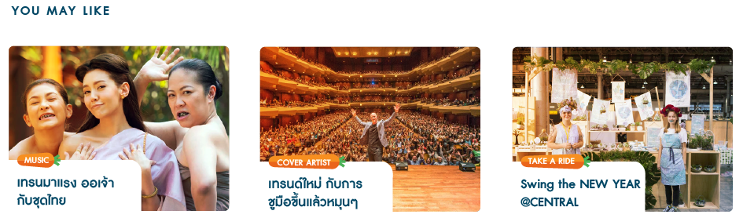

Screen 18: You May Like

|  |  |  |  |  |
| --- | --- | --- | --- | --- |
| **#** | **Component** | **Description** | **CMS** | |
|  | **Editable in Experience Editor** |
| 1 | Related Articles | * Each related articles displays following information:   + Thumbnail Image   + Category   + Name * After clicking on any related article, navigate to corresponding **Article Details** page | Able to edit section title (e.g. ‘YOU MAY LIKE’) | Able to edit section title (e.g. ‘YOU MAY LIKE’) |

### Advertisement (block)

Refer to 3.5.9

### Trending Post

Refer to 3.5.2. Articles belong to corresponding category.

## Events Landing

### Featured Events

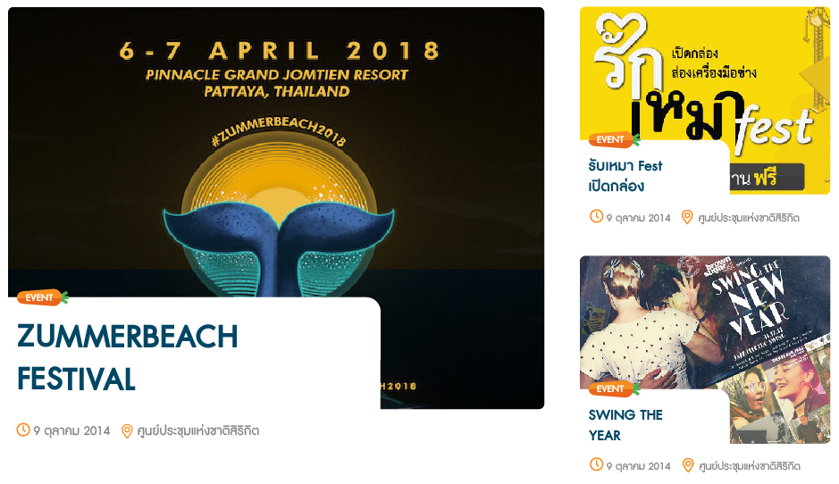

Screen 19: Featured Events

|  |  |  |  |  |
| --- | --- | --- | --- | --- |
| **#** | **Component** | **Description** | **CMS** | |
|  | **Editable in Experience Editor** |
| 1 | Featured Events | * Display top 3 events which satisfy selected filter option (only 1 option can be selected):  |  |  | | --- | --- | | **Filter Option** | **Logic** | | Most recent | Latest published events (based on published time) | | Top view in past 7 days | Events which have most viewed in the past 7 days | | Manual | Manually picked by administrator/editor in the backend |  * Each event displays following information:   + Thumbnail Image   + Category   + Name   + Start Date   + Venue * After clicking on any event (thumbnail image/ name), navigate user to corresponding **Event Details** page |  |  |

### Upcoming Events (vertical)

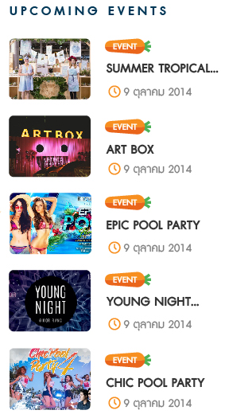

Screen 20: Upcoming Events (vertical)

|  |  |  |  |  |
| --- | --- | --- | --- | --- |
| **#** | **Component** | **Description** | **CMS** | |
|  | **Editable in Experience Editor** |
| 1 | Section Title |  | Able to edit title | Able to edit title |
| 2 | **Upcoming Events** list | * Display top 5 upcoming events (nearest to today) * Each event display following information:   + Thumbnail image   + Category   + Name   + Start Date * After clicking on any event (thumbnail image/ name), navigate user to corresponding **Event Details** page |  |  |

### Advertisement (horizontal)

Refer to 3.5.6

### Around The World

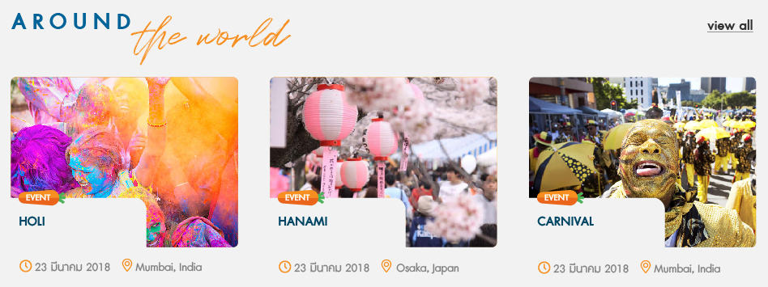

Screen 21: Around The World

|  |  |  |  |  |
| --- | --- | --- | --- | --- |
| **#** | **Component** | **Description** | **CMS** | |
|  | **Editable in Experience Editor** |
| 1 | Section Title |  | Able to edit title | Able to edit title |
| 2 | **Around The World** list | * Display top 3 upcoming oversea events (nearest to today) * Each event display following information:   + Thumbnail image   + Category   + Name   + Start Date   + Venue * After clicking on any event (thumbnail image/ name), navigate user to corresponding **Event Details** page |  |  |
| 3 | **view all** link | *(This feature is not in scope. Therefore, as of now, disable this link)* | Able to edit display text (e.g. ‘view all’) | Able to edit display text (e.g. ‘view all’) |

### Advertisement (block)

Refer to 3.5.9

### Latest Events

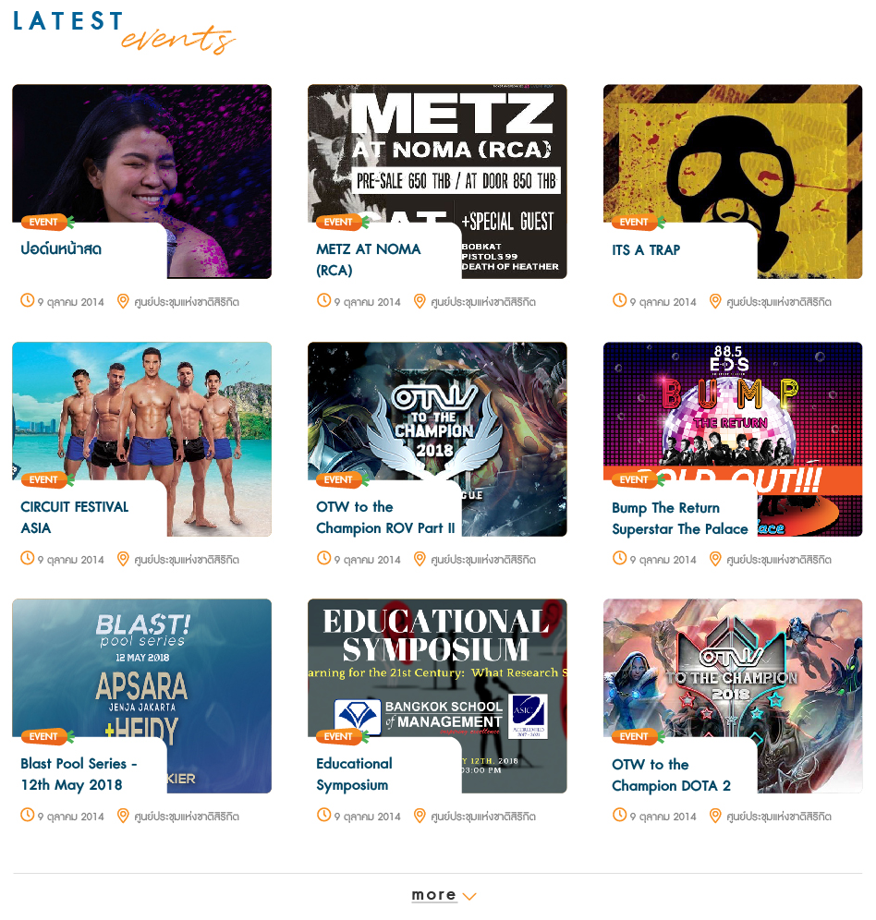

Screen 22: Latest Events

|  |  |  |  |  |
| --- | --- | --- | --- | --- |
| **#** | **Component** | **Description** | **CMS** | |
|  | **Editable in Experience Editor** |
| 1 | Section Title |  | Able to edit title | Able to edit title |
| 2 | **Latest Events** list | * Display top 9 recent events (based on published time, latest on will display first) * Each event display following information:   + Thumbnail image   + Category   + Name   + Start Date   + Venue * After clicking on any event (thumbnail image/ name), navigate user to corresponding **Event Details** page |  |  |
| 3 | **more** link | After clicking the link, display 9 more recent events | Able to edit display text (e.g. ‘more’, ‘less’) | Able to edit display text (e.g. ‘more’, ‘less’) |

### Advertisement (block)

Refer to 3.5.9

## Events Details

### Event Details

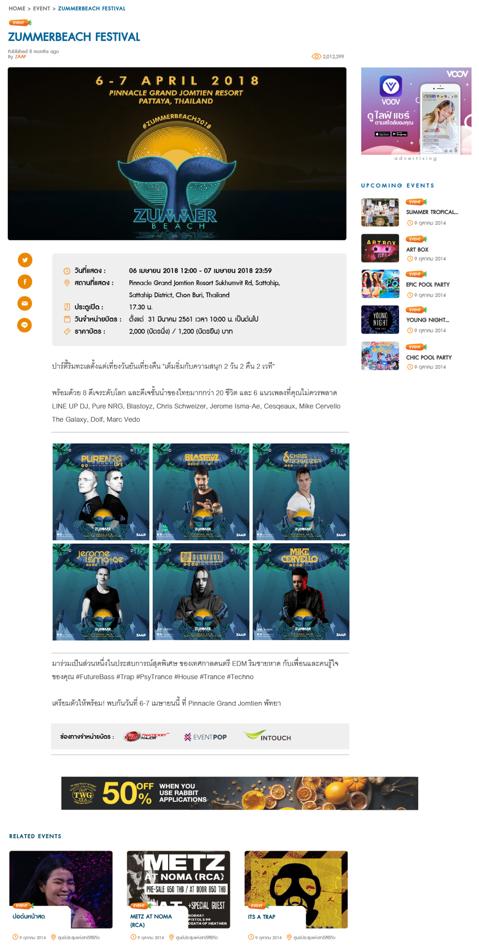

Screen 23: Event Details

|  |  |  |  |  |
| --- | --- | --- | --- | --- |
| **#** | **Component** | **Description** | **CMS** | |
|  | **Editable in Experience Editor** |
| 1 | Category |  |  |  |
| 2 | Name | Upper case |  |  |
| 3 | **Creation Information** | | | |
| 3.1 | Published time | State the time elapsed as follows:   |  |  | | --- | --- | | **Published Time** | **Text to display** | | > 1 day ago | Exact date: d MMM yyyy  E.g.: 20 May 2018 | | Yesterday | ‘yesterday’ | | Within 1 day ago & >= 1 hour ago | ‘n hours ago’  ‘1 hour ago’ | | Within 1 hour ago & >= 1 minute ago | ‘n minutes ago’  ‘1 minute ago’ | | Within 1 minute ago & >= 1 second ago | ‘n seconds ago’  ‘1 second ago’ | | Able to edit field label (e.g. ‘Published’) | Able to edit field label (e.g. ‘Published’) |
| 3.2 | Creator |  | Able to edit field label (e.g. ‘By) | Able to edit field label (e.g. ‘By) |
| 4 | **Number of views** | | | |
| 4.1 | Number of views | Number of views of the event |  |  |
| 5 | **Content** | | | |
| 5.1 | Banner |  |  |  |
| 5.2 | **Share** buttons | * User is able to share the event link via following social channels:   + Twitter   + Facebook   + Email   + LINE * Refer to * Share content |  |  |
| 5.3 | **Summary** block | Display following information:   * Time: {Start Date time} – {End Date time} * Venue: {Venue} * Door Opening Time: {Door Opening Time} * Tickets on Sale from: {Sale From} * Ticket Price: {Ticket Price} | Able to edit field labels | Able to edit field labels |
| 5.4 | Body | Main content of event |  |  |

### Advertisement (horizontal)

Refer to 3.5.6

### Related Events



Screen 24: Related Events

|  |  |  |  |  |
| --- | --- | --- | --- | --- |
| **#** | **Component** | **Description** | **CMS** | |
|  | **Editable in Experience Editor** |
| 1 | Related Events | * Each related event displays following information:   + Thumbnail Image   + Category   + Name   + Start Date   + Venue * After clicking on any related event, navigate to corresponding **Event Details** page | Able to edit section title (e.g. ‘RELATED EVENTS’) | Able to edit section title (e.g. ‘RELATED EVENTS’) |

## Generic Pages

### Blank Page

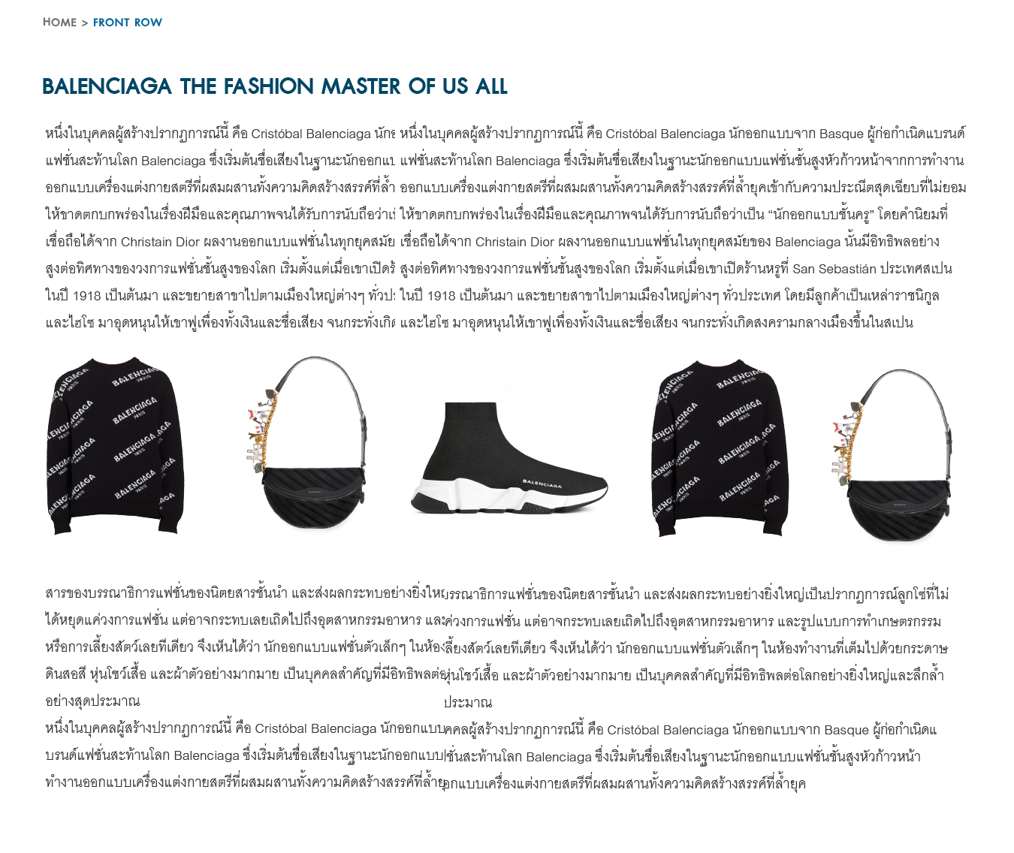

Screen 25: Blank Page

|  |  |  |  |  |
| --- | --- | --- | --- | --- |
| **#** | **Component** | **Description** | **CMS** | |
|  | **Editable in Experience Editor** |
| 1 | Title | Page title | Able to edit title | Able to edit title |
| 2 | Content | Rich text content | Able to edit content | Able to edit content |

## Search

### Search Bar

When user clicks on **Search** icon from header, display search bar below:

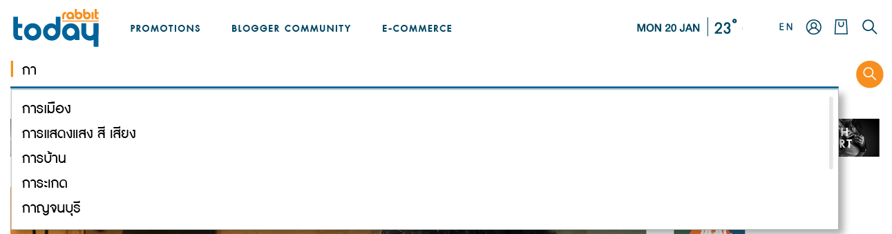

Screen 26: Search Bar

|  |  |  |  |  |
| --- | --- | --- | --- | --- |
| **#** | **Component** | **Description** | **CMS** | |
|  | **Editable in Experience Editor** |
| 1 | Search box | * When user types in keyword (at least 1 character), display suggested keywords (*) (maximum 10 keywords, 6 to tablet/mobile)   *(*) Suggested keywords:*   * + *Are keywords from most searched keywords & cloud tags*   + *Start with typed keyword* * After typing in keyword or selecting keyword from suggestion list, and clicks on **Search** icon or hit enter key, system performs search & navigate to **Search Results** page * Refer to Search | * Able to edit placeholder text * Able to configure maximum number of suggested keywords displaying in desktop, tablet, mobile | Able to edit placeholder text |

### Search Results

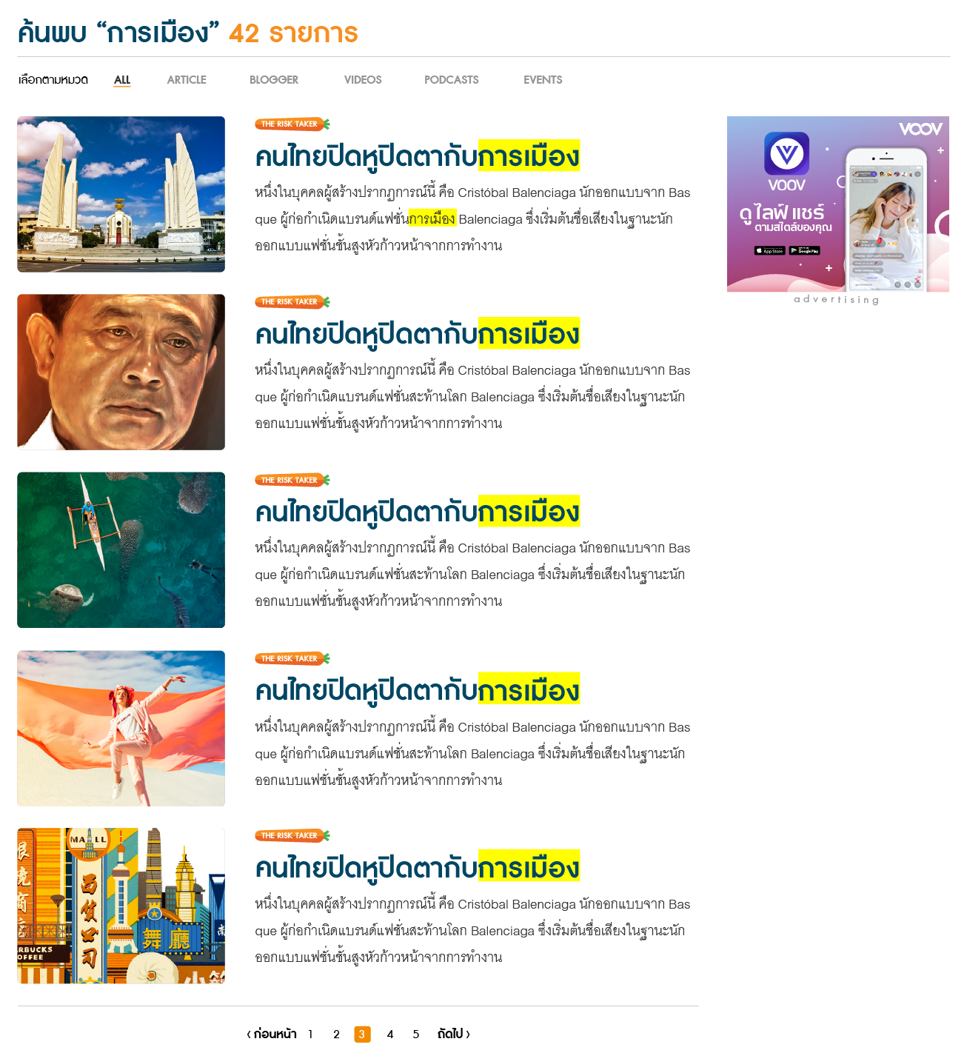

Screen 27: Search Results

|  |  |  |  |  |
| --- | --- | --- | --- | --- |
| **#** | **Component** | **Description** | **CMS** | |
|  | **Editable in Experience Editor** |
| 1 | **Number of items found** label | Combination string of:   * More than 1 items found:   *Found “keyword” {number of items found} items*   * 1 item found:   *Found “keyword” 1 item*   * No items found:   *Sorry, we can’t find any item matching your search. (*MSG 1*)* | Able to edit text of ‘found’ & ‘items’ | Able to edit text of ‘found’ & ‘items’ |
| 2 | Filter (by categories) | * Display content types from search results (& ‘ALL’ option). Following types are available:  |  |  | | --- | --- | | **Type** | **Description** | | ALL | All contents | | ARTICLE | All articles having category <> ‘Outsource Writer’ | | BLOGGER | Articles having category = ‘Outsource Writer’ | | VIDEOS | Video contents | | PODCASTS | Podcast contents | | EVENTS | Event contents |  * Default selected filter: ‘ALL’ * After selecting any option, re-filter search results | * Able to edit label of ‘Choose by categories’ & ‘ALL’ * Able to edit content type name (e.g. Article, Videos, Podcasts, Events) | Able to edit label of ‘Choose by categories’ & ‘ALL’ |
| 3 | Results list | * Leverage on Lucene scoring formula so that best search results are returned first * Keywords found in search results are highlighted in yellow. * Each item displays following information:   + Thumbnail Image   + Category   + Name   + Summary * Paging: 5 |  |  |
| 4 | Advertisement (block) | Refer to 3.5.9 |  |  |

## Video/Podcast Details

### Video/Podcast Details

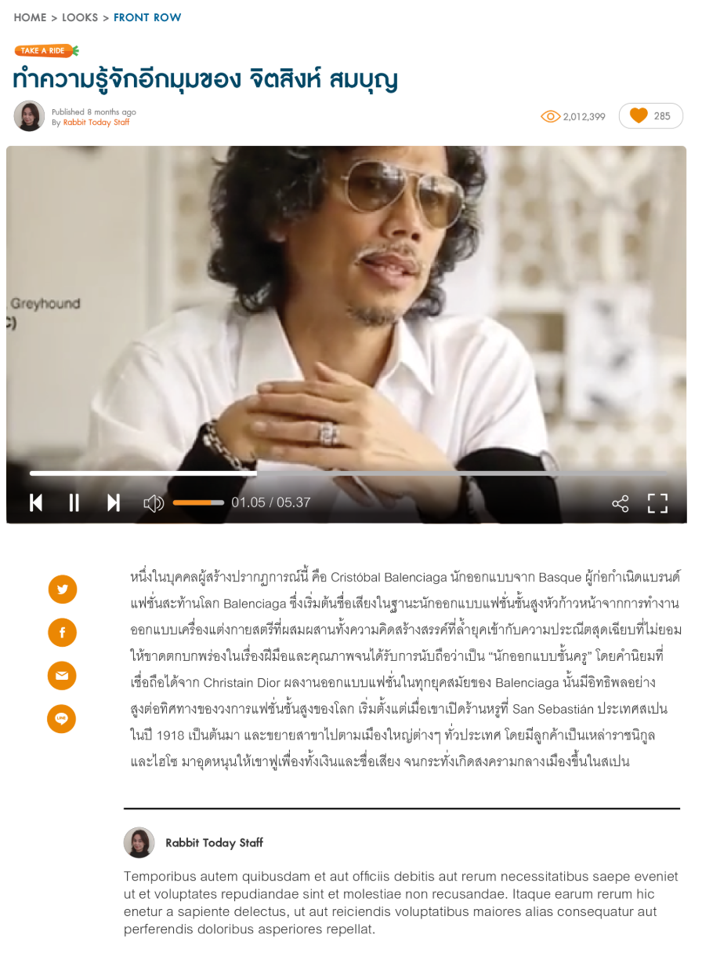

Screen 28: Video/Podcast Details

|  |  |  |  |  |
| --- | --- | --- | --- | --- |
| **#** | **Component** | **Description** | **CMS** | |
|  | **Editable in Experience Editor** |
| 1 | Category |  |  |  |
| 2 | Name | Upper case |  |  |
| 3 | **Creation Information** | | | |
| 3.1 | Creator’s avatar |  |  |  |
| 3.2 | Published time | State the time elapsed as follows:   |  |  | | --- | --- | | **Published Time** | **Text to display** | | > 1 day ago | Exact date: d MMM yyyy  E.g.: 20 May 2018 | | Yesterday | ‘yesterday’ | | Within 1 day ago & >= 1 hour ago | ‘n hours ago’  ‘1 hour ago’ | | Within 1 hour ago & >= 1 minute ago | ‘n minutes ago’  ‘1 minute ago’ | | Within 1 minute ago & >= 1 second ago | ‘n seconds ago’  ‘1 second ago’ | | Able to edit field label (e.g. ‘Published’) | Able to edit field label (e.g. ‘Published’) |
| 3.3 | Creator |  | Able to edit field label (e.g. ‘By) | Able to edit field label (e.g. ‘By) |
| 4 | **Number of views, likes** | | | |
| 4.1 | Number of views | Number of views of the video/podcast |  |  |
| 4.2 | Number of likes  **Like** button | * Number of likes of the video/podcast * Allow user to like/unlike the video/podcast:   + Not-yet-liked state:   C:\Users\smartosc\AppData\Local\Temp\SNAGHTML53a8ec0e.PNG   * + Liked state:   C:\Users\smartosc\AppData\Local\Temp\SNAGHTML53aa69d4.PNG  Refer to  Like content &   * Unlike content |  |  |
| 5 | **Content** | | | |
| 5.1 | Video/Podcast | * Automatically play video/podcast using Iframe Player API on page load * Video/Podcast is Youtube link |  |  |
| 5.2 | **Share** buttons | * User is able to share the video/podcast link via following social channels:   + Twitter   + Facebook   + Email   + LINE * Refer to * Share content |  |  |
| 5.3 | Body | Main content of video/podcast |  |  |
| 5.4 | Creator’s quotes | Quotes about creator |  |  |

### You May Like



Screen 29: You May Like

|  |  |  |  |  |
| --- | --- | --- | --- | --- |
| **#** | **Component** | **Description** | **CMS** | |
|  | **Editable in Experience Editor** |
| 1 | Related Contents | * Each related content displays following information:   + Thumbnail Image   + Category   + Name * After clicking on any related content, navigate to corresponding **Details** page (Article Details/ Event Details/ Video/Podcast Details) | Able to edit section title (e.g. ‘YOU MAY LIKE’) | Able to edit section title (e.g. ‘YOU MAY LIKE’) |

### Advertisement (block)

Refer to 3.5.9

### Trending Post

Refer to 3.5.2

# Use Case Specifications

This section covers the system’s functional requirements which details what the system must do in terms of input, behavior and the expected output. It elicits the interaction between the actor(s) and the system, the system’s behavior and the results of their interactions.

## Back-end

### Create draft content

|  |  |
| --- | --- |
| **Objective** | Allow user to create content and save it as draft |
| **Actor** | Authenticated users |
| **Trigger** | User tends to create draft content. |
| **Pre-condition** | N/A |
| **Post-condition** | Content is saved as draft. |

**Activities Flow**

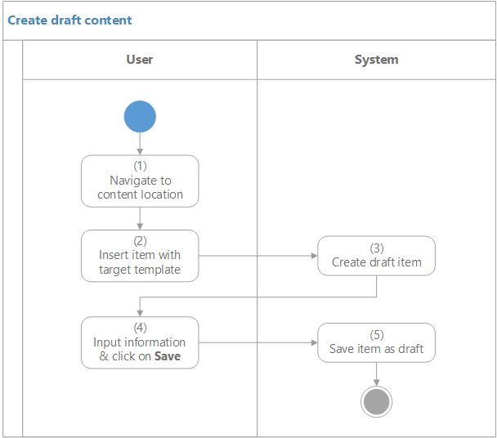

**Business Rules**

|  |  |  |
| --- | --- | --- |
| Step | BR Code | Description |
| (5) | BR 1 | Set content status to ‘Draft’ |

### Edit content

|  |  |
| --- | --- |
| **Objective** | Allow user to edit content |
| **Actor** | Authenticated users |
| **Trigger** | User tends to edit content. |
| **Pre-condition** | N/A |
| **Post-condition** | Content is updated. |

**Activities Flow**

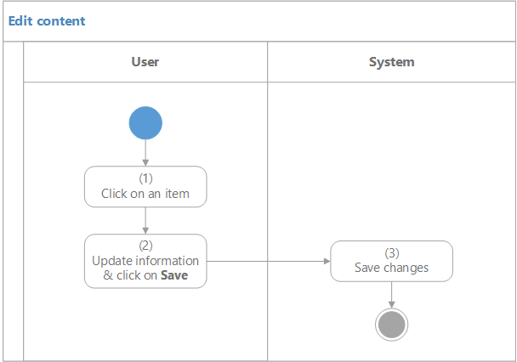

**Business Rules**

N/A

### Delete content

|  |  |
| --- | --- |
| **Objective** | Allow user to delete content |
| **Actor** | Authenticated users |
| **Trigger** | User tends to delete content. |
| **Pre-condition** | N/A |
| **Post-condition** | Content is moved to Recycle Bin. |

**Activities Flow**

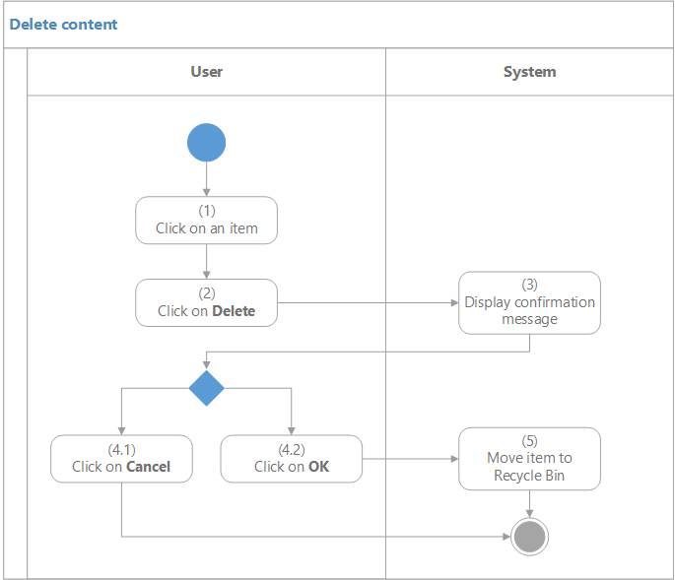

**Business Rules**

N/A

### Submit content

|  |  |
| --- | --- |
| **Objective** | Allow user to submit content for approval |
| **Actor** | * User has either one of following roles:   + Author   + Editor   + Administrator |
| **Trigger** | User tends to submit content. |
| **Pre-condition** | * Content has either one of following statuses:   + ‘Draft’   + ‘Rejected’   + ‘Unpublished’ |
| **Post-condition** | * Content is submitted. * Content status is changed to ‘Submitted’ |

**Activities Flow**

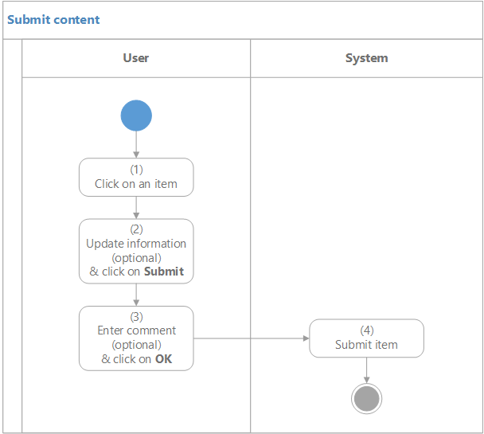

**Business Rules**

|  |  |  |
| --- | --- | --- |
| Step | BR Code | Description |
| (4) | BR 2 | Set content status to ‘Submitted’ |

### Publish content

|  |  |
| --- | --- |
| **Objective** | Allow user to publish content |
| **Actor** | * User has either one of following roles:   + Editor   + Administrator |
| **Trigger** | User tends to publish content. |
| **Pre-condition** | Content status is ‘Submitted’ |
| **Post-condition** | Content is published to Rabbit Today site. |

**Activities Flow**

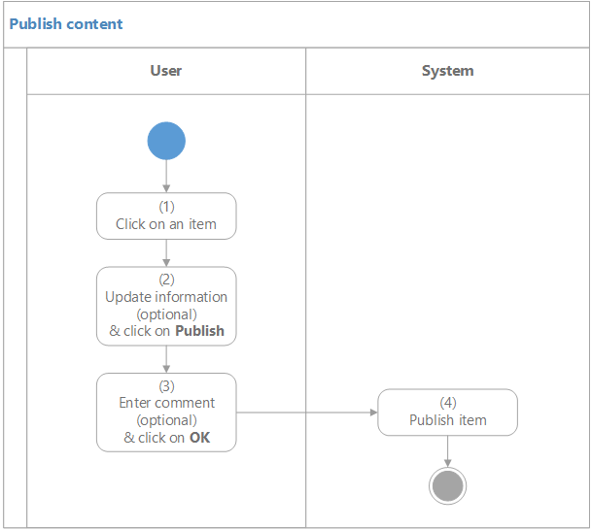

**Business Rules**

|  |  |  |
| --- | --- | --- |
| Step | BR Code | Description |
| (4) | BR 3 | * Publish content to Rabbit Today site * Set content status to ‘Published |

### Reject content

|  |  |
| --- | --- |
| **Objective** | Allow user to reject content for amendment |
| **Actor** | * User has either one of following roles:   + Editor   + Administrator |
| **Trigger** | User tends to reject content. |
| **Pre-condition** | Content status is ‘Submitted’ |
| **Post-condition** | Content is rejected. |

**Activities Flow**

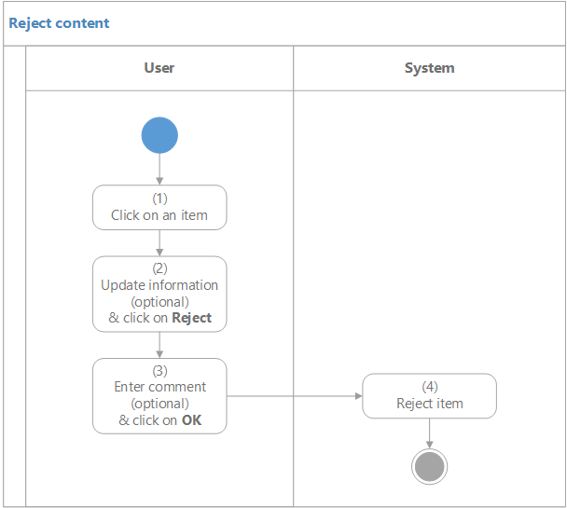

**Business Rules**

|  |  |  |
| --- | --- | --- |
| Step | BR Code | Description |
| (4) | BR 4 | * Set content status to ‘Rejected’ * Send notification email EML 1 to creator of the content |

### Unpublish content

|  |  |
| --- | --- |
| **Objective** | Allow user to unpublish content |
| **Actor** | * User has either one of following roles:   + Editor   + Administrator |
| **Trigger** | User tends to unpublish content. |
| **Pre-condition** | N/A |
| **Post-condition** | Content is unpublished. Content is no longer available in Rabbit Today site. |

**Activities Flow**

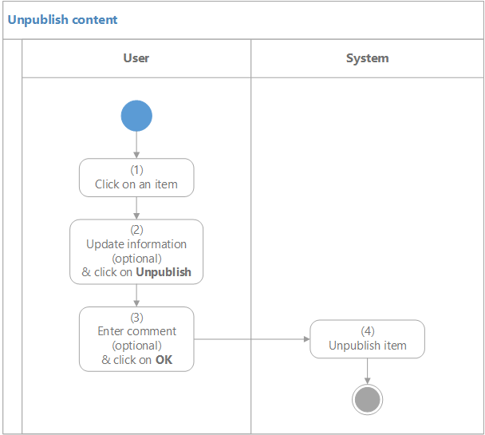

**Business Rules**

|  |  |  |
| --- | --- | --- |
| Step | BR Code | Description |
| (4) | BR 5 | * Unpublish content on Rabbit Today site * Set content status to ‘Unpublished’ * Send notification email EML 2 to creator of the content |

### Scheduled Publish content

|  |  |
| --- | --- |
| **Objective** | Allow user to configure publishing period for item |
| **Actor** | * User has either one of following roles:   + Editor   + Administrator |
| **Trigger** | User tends to configure publishing period for item |
| **Pre-condition** | N/A |
| **Post-condition** | Content is scheduled for publishing |

**Business Rules**

|  |  |  |
| --- | --- | --- |
| Step | BR Code | Description |
|  | BR 6 | Editor & Administrator is able to configure when item is scheduled for publish and when item is unpublished. |
|  | BR 7 | Selected content will be published regardless of its status. |

## Rabbit Today site

### Search

|  |  |
| --- | --- |
| **Objective** | Allow user to search for content |
| **Actor** | All users |
| **Trigger** | User tends to search for content. |
| **Pre-condition** | N/A |
| **Post-condition** | Contents matching criteria display in the results list below. |

**Activities Flow**

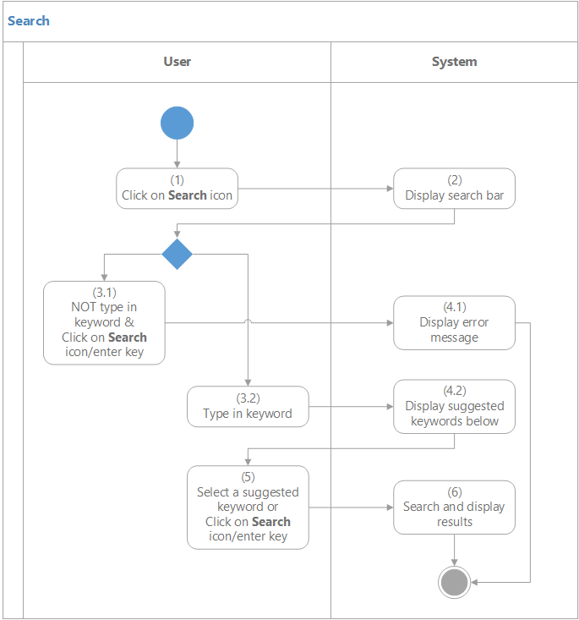

**Business Rules**

|  |  |  |
| --- | --- | --- |
| Step | BR Code | Description |
| (4.1) | BR 8 | As keyword is required, then if user does not input keyword, system will display error message MSG 2 |
| (4.2) | BR 9 | When user types in keyword (at least 1 character), display suggested keywords (*) (maximum 10 keywords, 6 to tablet/mobile)  *(*) Suggested keywords:*   * + *Are keywords from most searched keywords & cloud tags*   + *Start with typed keyword* |
| (6) | BR 10 | * Search and display all results matching keyword (*) and take user to **Search Results** page.   *(*) Returned contents have following fields contain inputted keyword:*   |  |  | | --- | --- | | ***Content Type*** | ***Searchable fields*** | | *Article* | * + *Name*   + *Summary*   + *Body*   + *Tags* | | *Event* | * + *Name*   + *Summary*   + *Body*   + *Venue*   + *Tags* | | *Video/Podcast* | * + *Name*   + *Summary*   + *Body*   + *Tags* |  * Leverage on Lucene scoring formula so that best search results are returned first * Keywords found in search results are highlighted in yellow. * Each item displays following information:   + Thumbnail Image   + Category   + Name   + Summary |

### Subscribe (Email)

|  |  |
| --- | --- |
| **Objective** | Allow user to register his email to receive Rabbit Today e-newsletters |
| **Actor** | All users |
| **Trigger** | User tends to subscribe to Rabbit Today e-newsletter. |
| **Pre-condition** | N/A |
| **Post-condition** | Email of user is added to subscription list. |

**Activities Flow**

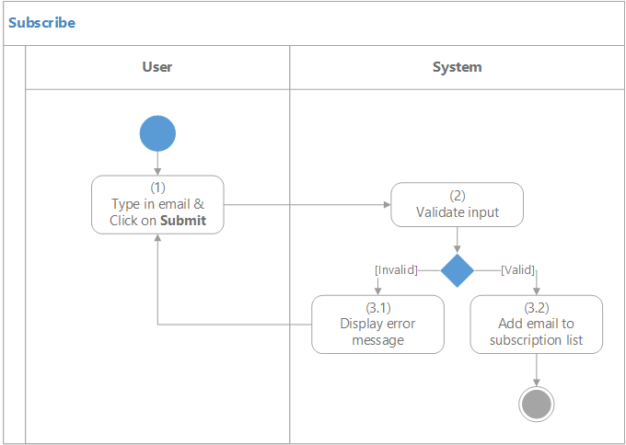

**Business Rules**

|  |  |  |
| --- | --- | --- |
| Step | BR Code | Description |
| (2)  (3.1) | BR 11 | | **Error** | **Error message** | | --- | --- | | Email is left blank | MSG 3 | | Invalid email address format | MSG 4 | | Email has already been registered | MSG 5 | |
| (3.2) | BR 12 | * Add email into pre-defined subscription list which is manageable in the backend * Display successful message MSG 6 & hide **Email** text box, **Submit** button until next page load |

### Like content

|  |  |
| --- | --- |
| **Objective** | Allow user to like the content (article & video/podcast) |
| **Actor** | All users |
| **Trigger** | User tends to like the content |
| **Pre-condition** | Content has not been liked by the user. |
| **Post-condition** | Content is liked by the user. |

**Activities Flow**

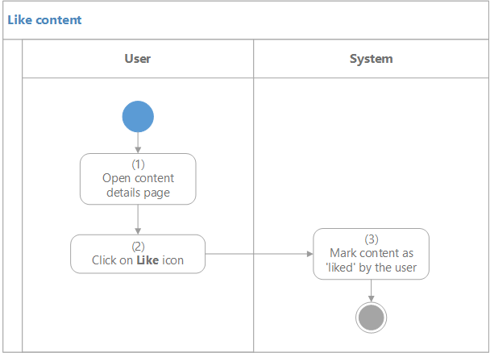

**Business Rules**

N/A

### Unlike content

|  |  |
| --- | --- |
| **Objective** | Allow user to unlike the content (article & video/podcast) |
| **Actor** | All users |
| **Trigger** | User tends to unlike the content |
| **Pre-condition** | Content has been liked by the user. |
| **Post-condition** | ‘Like’ of the user is removed. |

**Activities Flow**

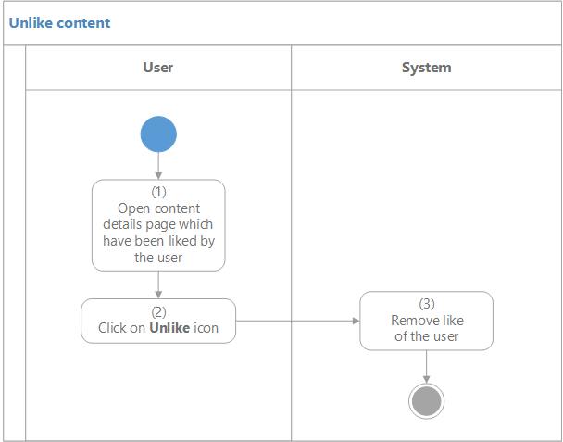

**Business Rules**

N/A

### Share content

|  |  |
| --- | --- |
| **Objective** | Allow user to share the content via social channels |
| **Actor** | All users |
| **Trigger** | User tends to share the content link. |
| **Pre-condition** | N/A |
| **Post-condition** | Content is able to share via selected social channel. |

**Activities Flow**

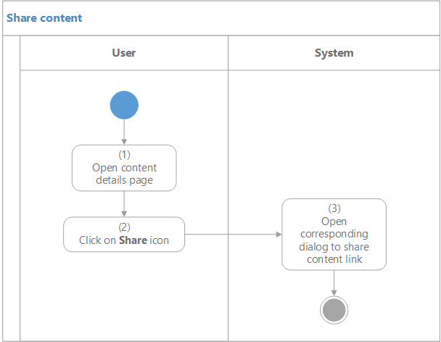

**Business Rules**

|  |  |  |
| --- | --- | --- |
| Step | BR Code | Description |
|  | BR 13 | Using Sitecore Social Connect |

## Ads Management

**Business Rules**

|  |  |
| --- | --- |
| BR Code | Description |
| BR 14 | **Display order**:   * Maximum ads to display: 20 (this number is configurable in the backend) * Manually selected ads in backend will be displayed first, the rest (Maximum ads – manually selected ads) will be ordered by impression rate in ascending order * Ad will no longer display when it reaches the limit (E.g. impression limit is 1000. If impression rate of an ad reaches 1000, that ad will no longer display in Rabbit site). Limit number is configurable in the backend, refer to BR **18**. * **Category Landing** page: Able to select categories of ads to display on specific Category Landing page. (E.g.: In ‘Smart Living’ category page will display ads of ‘Furniture’, ‘Home Décor’) * Use common data source for ads in all blocks of a single page. E.g. 2 ads blocks in Home page will display same ads (& also their display order will be the same in these 2 blocks) |
| BR 15 | **Impression Rate**:  The impression counts of a single ad will be as follows:   * When ad A is displayed, count + 1 * As there are multiple ad blocks in a page, so that when user scrolls down to next block & again ad A is displayed, count + 1 * When user stays in page where ad block displays, ad A might display multiple times, count + n times (e.g. 10 times, count + 10) |
| BR 16 | **Click Rate**:  The click counts of a single ad will be as follows:   * When ad A is clicked, count + 1 |
| BR 17 | **Analytics**:  Custom report for ads tracking in Sitecore Analytics (refer to Screen 30: Ad Analytics)   * Able to select date range (within one year) to run the report * **Summary**:   + Impression rates: Total impression rates of all ads in selected date range   + Click rates: Total click rates of all ads in selected date range * **Impression & Click rates per day** * **Impression & Click rates per category** * **Ads list**: List out all ads with its category, impression rate & click rate |
| BR 18 | **Impression Limit**:  There are 2 settings for impression limit: (1) global limit and (2) ad limit. Ad limit is for specific ad & always override global limit while global limit is applied to ads that have not-set limit.   * If ad limit = 0 🡪 Ad always displays (no limit) * If ad limit = blank (not set) 🡪 System uses global limit * If ad limit = any value greater than 0 🡪 System uses ad limit * If global limit = 0 or blank (not set) 🡪 System displays ads that have not-set limit without limit. |

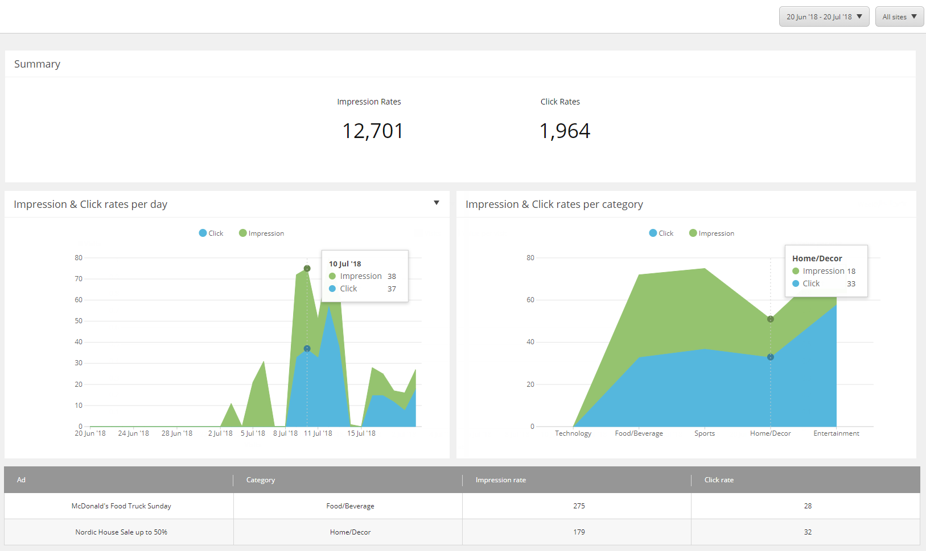

Screen 30: Ad Analytics

# Data Templates

This section defines data templates to be used over the project. Each data template defines a data type. Sitecore associates a data template with each item. The data template defines the structure of all items associated with that data template. A data template contains a number of data template sections, each of which contains a number of data template fields.

## Article

|  |  |  |  |  |
| --- | --- | --- | --- | --- |
| **DT 1** (Article) |  | |  |  |
| **Name** | **Type** | **Source** | | **Shared** |
| Name | Single-Line Text |  | | No |
| Banner | Image |  | | Yes |
| Thumbnail Image | Image |  | | Yes |
| Body | Rich Text (with snippet) |  | | No |
| Related Articles | Tree list |  | | Yes |
| Summary | Multi-Line Text |  | | No |

## Event

|  |  |  |  |  |
| --- | --- | --- | --- | --- |
| **DT 2** (Event) |  | |  |  |
| **Name** | **Type** | **Source** | | **Shared** |
| Name | Single-Line Text |  | | No |
| Banner | Image |  | | Yes |
| Thumbnail Image | Image |  | | Yes |
| Oversea | Checkbox |  | | Yes |
| Start Date Time | Date Time |  | | Yes |
| End Date Time | Date Time |  | | Yes |
| Venue | Single-Line Text |  | | No |
| Door Opening Time | Single-Line Text |  | | No |
| Ticket Sale From | Single-Line Text |  | | No |
| Ticket Price | Single-Line Text |  | | No |
| Body | Rich Text (with snippet) |  | | No |
| Related Events | Tree list |  | | Yes |
| Summary | Multi-Line Text |  | | No |

## Video/Podcast

|  |  |  |  |  |
| --- | --- | --- | --- | --- |
| **DT 3** (Video/Podcast) |  | |  |  |
| **Name** | **Type** | **Source** | | **Shared** |
| Name | Single-Line Text |  | | No |
| URL | General Link |  | | Yes |
| Thumbnail Image | Image |  | | Yes |
| Body | Rich Text (with snippet) |  | | No |
| Related Articles | Tree list |  | | Yes |
| Summary | Multi-Line Text |  | | No |

# Non-Functional Requirements

This section describes the operation of the system with respect to the **Use Case Specifications** section (Functional requirements). This comprises mostly of the technical architecture of the system which could be referred to as the quality of the system.

## Performance Requirements (optional)

<If there are performance requirements for the product under various circumstances, state them here and explain their rationale, to help the developers understand the intent and make suitable design choices. Specify the timing relationships for real time systems. Make such requirements as specific as possible. You may need to state performance requirements for individual functional requirements or features.>

## Safety Requirements (optional)

<Specify those requirements that are concerned with possible loss, damage, or harm that could result from the use of the product. Define any safeguards or actions that must be taken, as well as actions that must be prevented. Refer to any external policies or regulations that state safety issues that affect the product’s design or use. Define any safety certifications that must be satisfied.>

## Security Requirements (optional)

<Specify any requirements regarding security or privacy issues surrounding use of the product or protection of the data used or created by the product. Define any user identity authentication requirements. Refer to any external policies or regulations containing security issues that affect the product. Define any security or privacy certifications that must be satisfied.>

## Software Quality Attributes (optional)

<Specify any additional quality characteristics for the product that will be important to either the customers or the developers. Some to consider are: adaptability, availability, correctness, flexibility, interoperability, maintainability, portability, reliability, reusability, robustness, testability, and usability. Write these to be specific, quantitative, and verifiable when possible. At the least, clarify the relative preferences for various attributes, such as ease of use over ease of learning.>

# Integration

## Google Analytics

Add Google Analytics script into Rabbit Today website for measuring how users interact with the website

The script is as embedded.



# Appendices

## Messages List

*(All messages are multilingual and editable in the backend.)*

|  |  |  |
| --- | --- | --- |
| **#** | **Message Code** | **Message** |
| 1 | MSG 1 | Sorry, we can’t find any item matching your search. |
| 2 | MSG 2 | Please enter keyword, at least 1 character. |
| 3 | MSG 3 | Please enter your email. |
| 4 | MSG 4 | Please enter a correct email. |
| 5 | MSG 5 | This email has already been registered. |
| 6 | MSG 6 | Thank you for subscribing. |

## Email Templates

*(All email templates are multilingual and editable in the backend.)*

|  |  |  |
| --- | --- | --- |
| **#** | **Email Code** | **Content** |
| 1 | EML 1 | **Logic**: When content is rejected |
| * **To**: who created the content * **Subject**: Rabbit Today – Your content has been rejected * **Body**:   Hi {user’s full name},  Your content of “{content’s name}” has been rejected.  Reason: “{comment}”  Please make modifications to your content and re-submit it.  Best regards,  Rabbit Today team |
| 2 | EML 2 | **Logic**: When content is un-published |
| * **To**: who created the content * **Subject**: Rabbit Today – Your content has been un-published * **Body**:   Hi {user’s full name},  Your content of “{content’s name}” has been un-published.  Reason: “{comment}”  Please make modifications to your content and re-submit it.  Best regards,  Rabbit Today team |

## Snippet

*Small HTML that can be inserted into a HTML field*

### Quote



Screen 31: Snippet – Quote